**Spanning Tree and Minimum Spanning Tree**

Before we learn about spanning trees, we need to understand two graphs: undirected graphs and connected graphs.

An **undirected graph** is a graph in which the edges do not point in any direction (ie. the edges are bidirectional).

|  |
| --- |
| Undirected Graph |
| Undirected Graph |

A **connected graph** is a graph in which there is always a path from a vertex to any other vertex.

|  |
| --- |
| Connected Graph |
| Connected Graph |

## Spanning tree

A spanning tree is a sub-graph of an undirected connected graph, which includes all the vertices of the graph with a minimum possible number of edges. If a vertex is missed, then it is not a spanning tree.

The edges may or may not have weights assigned to them.

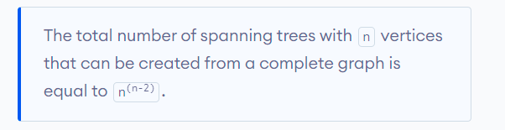

If we have n = 4, the maximum number of possible spanning trees is equal to 44-2 = 16. Thus, 16 spanning trees can be formed from a complete graph with 4 vertices.

## Example of a Spanning Tree

Let's understand the spanning tree with examples below:

Let the original graph be:

|  |
| --- |
| initial tree |
| Normal graph |

Some of the possible spanning trees that can be created from the above graph are:

|  |
| --- |
| spanning tree |
| A spanning tree |

|  |
| --- |
| spanning tree |
| A spanning tree |

|  |
| --- |
| spanning tree |
| A spanning tree |

|  |
| --- |
| spanning tree |
| A spanning tree |

|  |
| --- |
| spanning tree |
| A spanning tree |

|  |
| --- |
| spanning tree |
| A spanning tree |

## Minimum Spanning Tree

A minimum spanning tree is a spanning tree in which the sum of the weight of the edges is as minimum as possible

## Example of a Spanning Tree

Let's understand the above definition with the help of the example below.

The initial graph is:

|  |
| --- |
| initial graph |
| Weighted graph |

The possible spanning trees from the above graph are:

|  |
| --- |
| minimum spanning tree (mst) |
| Minimum spanning tree - 1 |

|  |
| --- |
| minimum spanning tree (mst) |
| Minimum spanning tree - 2 |

|  |
| --- |
| minimum spanning tree (mst) |
| Minimum spanning tree - 3 |

|  |
| --- |
| minimum spanning tree (mst) |
| Minimum spanning tree - 4 |

The minimum spanning tree from the above spanning trees is:

|  |
| --- |
| minimum spanning tree (mst) |
| Minimum spanning tree |

The minimum spanning tree from a graph is found using the following algorithms:

1. Prim's Algorithm
2. Kruskal's Algorithm

## Spanning Tree Applications

* Computer Network Routing Protocol
* Cluster Analysis
* Civil Network Planning

## Minimum Spanning tree Applications

* To find paths in the map
* To design networks like telecommunication networks, water supply networks, and electrical grids.